**Export & re-create vivado block design** (zcu216, vivado 2020.2,qick repo fb4a08f**)**

Link to the version of qick that is used to generate the results in this section is here:

<https://github.com/openquantumhardware/qick/tree/fb4a08fc544345af344e129b6d7c1bd98cf914f3>

export vivado block design

Let’s say you have the following block design that you want to export to a “.tcl” file for distribution and which can be re-created by following the steps in *re-create vivado block design* section:

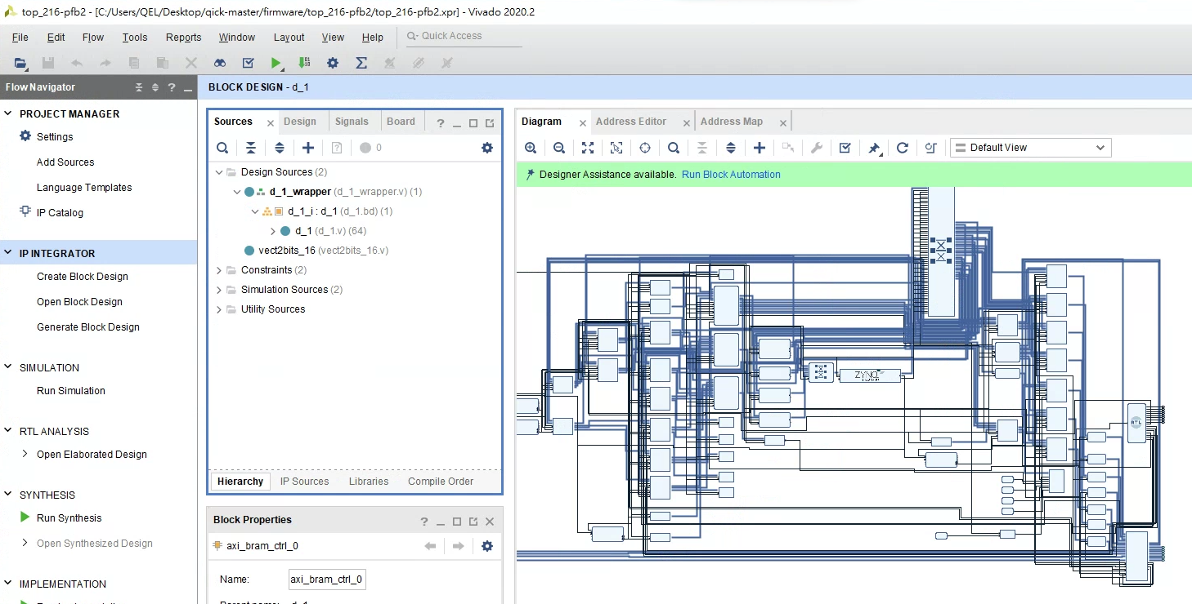

* Step1. File -> Export -> Export Block Design, then give it a name e.g. “bd_216-pfb2.tcl” and choose a location to save.

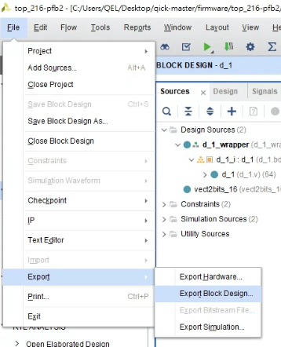

* Step2. Copy the codes at:

<https://github.com/Ri-chard-Wu/thesis/blob/master/codes/axis_pfb_readout_v2-test-216/proj_216-pfb2.tcl>

The following two lines may need to be modified:

Change "top_216-pfb2" to whatever name you want, or leave it as it is.



The “bd_216-pfb2.tcl” need to match the name of the block design script that we exported in step1 above. Here it already is matched.



Now we have the two scripts “bd_216-pfb2.tcl” and “proj_216-pfb2.tcl”. Now you can follow the steps in *re-create vivado block design* section to re-created the block design.

re-create vivado block design

After exporting a block design following the section [*export vivado block design*](/9f684e3c8e3840ed8335da996ff4ab75?pvs=25#0572e73216a34bed84df14a3de103800) above, we will obtain two files in the form “bd_216 … .tcl”, “proj_216 … .tcl”. These two are used to re-create the vivado block design. Following I will show you the steps to re-create vivado design with an example.

* Step1. Download and unzip the qick repo (fb4a08f) into a directory e.g. “qick-master”:

<https://github.com/openquantumhardware/qick/tree/fb4a08fc544345af344e129b6d7c1bd98cf914f3>

* Step2. Download the scripts “bd_216-pfb2.tcl” and “proj_216-pfb2.tcl” at:

<https://github.com/Ri-chard-Wu/thesis/tree/master/codes/axis_pfb_readout_v2-test-216>

* Step3. Move “bd_216-pfb2.tcl” to “qick-master/firmware/bd”, and move “proj_216-pfb2.tcl” to “qick-master/firmware”
* Step4. Open vivado (2020.2). Then, in Tcl Console, cd to “qick-master/firmware”, and source the “proj_216-pfb2.tcl” script:

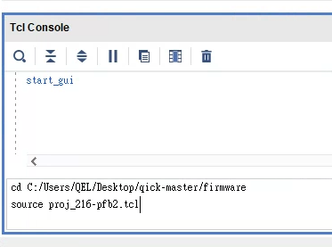

* Step5. If it all goes well, you should see the following. There should not be any error messages in the *Tcl Console* tab or *Messages* tab.

